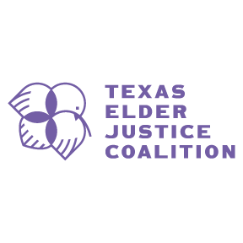 | 2025 TEJC Summit Scholarship Application  Texas Elder Justice Coalition Summit  Tuesday, June 10, 2025  APPLICATION DUE: Monday, May 5, 2025  NOTIFICATIONS BY: Monday, May 12, 2025
The Texas Elder Justice Coalition (TEJC) is pleased to offer a limited number of scholarships to cover the cost of registration for the 2025 TEJC Summit, either in person or virtually. These scholarships aim to increase access for professionals, students, and community members committed to advancing elder justice across Texas.
DUE: Monday, May 5, 2025 by 5pm, email to: dhoffman@guardianshipservices.org
Questions? Contact Dana Hoffman dhoffman@guardianshipservices.org

Applicant Information
Full Name:
Email Address:
Phone Number:
Mailing Address:
Organization/Employer (if applicable):
Role/Title:

Questions
1. How does your work or interest align with elder justice and the goals of TEJC? (100–300 words/5-15 lines)
-
-
-
-
-
-
2. How will attending the summit benefit your local community? Describe your vision of collaborative work with Law Enforcement, District/County Attorneys, Adult Protective Services, Community Organizations, Financial Institutions, Victim Services or other organizations. (100–300 words/5-15 lines)
-
-
-
-
-
-
-
-

Reference
Full Name:
Email Address:
Phone Number:
Organization/Employer (if applicable):
Role/Title:

Attendance Preference
___ I plan to attend **in person** in Fort Worth, TX
___ I plan to attend **virtually**

Volunteer Availability
___ I can volunteer 1-2 hours before or during the Summit
___ I can volunteer 1- 2 hours in person the week prior to the Summit
___ I can volunteer 1- 2 hours remotely the week prior to the Summit
___ I am unable to volunteer

